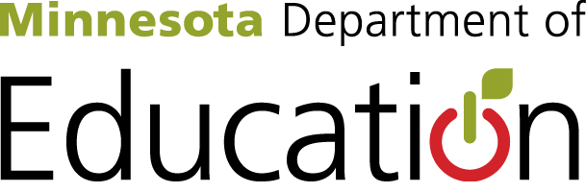

Current School Readiness Statute requires limited program standards and very little accountability toward ensuring children are prepared for kindergarten.
Research states very clearly that in order to best prepare children for kindergarten certain early learning program standards must be implemented.
The area of highest concern is the duration and intensity requirement of SR does not come close to meeting standards set for achieving impact on school readiness.
Of the researched high-quality program standards, our current SR Statute only meets 5 out of 18 high-quality program standards. Standards that are not met are highlighted below.
High-Quality Preschool Program means an early learning program that includes structural elements that are evidence-based and nationally recognized as important for ensuring program quality, including at a minimum--
- High staff qualifications, including a teacher with a bachelor’s degree in early childhood education or a bachelor’s degree in any field with a State-approved alternate pathway, which may include coursework, clinical practice, and evidence of knowledge of content and pedagogy relating to early childhood, and teaching assistants with appropriate credentials;
- High-quality professional development for all staff;
- A child-to-instructional staff ratio of no more than 10 to 1;
- A class size of no more than 20 with, at a minimum, one teacher with high staff qualifications
- A Full-Day program;
- Inclusion of children with disabilities to ensure access to and full participation in all opportunities;
- Developmentally appropriate, culturally and linguistically responsive instruction and evidence-based curricula, and learning environments that are aligned with the State Early Learning and Development Standards
- Individualized accommodations and supports so that all children can access and participate fully in learning activities;
- Instructional staff salaries that are comparable to the salaries of local K-12 instructional staff;
- Parent engagement strategies
- Program evaluation to ensure continuous improvement;
- On-site or accessible Comprehensive Services for children and community partnerships that promote families’ access to services that support their children’s learning and development; and
- Evidence-based health and safety standards.
- Measurement of each child’s cognitive and social skills using formative measure when child enters and again upon exit
- Screening and Progress Monitoring Measures
- Measures of Environmental Quality
- Measures of the Quality of Adult-Child Interactions
- Kindergarten Entry Assessment

