July 16, 2015

Senator Mitch McConnell
Majority Leader
U.S. Senate
Washington, D.C. 20510

Senator Harry Reid
Democratic Leader
U.S. Senate
Washington, D.C. 20510
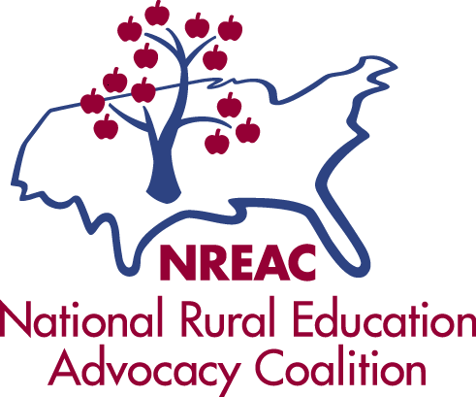

Senator Lamar Alexander
Chairman, Senate HELP Committee
U.S. Senate
Washington, D.C. 20510

Senator Patty Murray
Ranking Member, Senate HELP Committee
U.S. Senate
Washington, D.C. 20510

Dear Senators,

On behalf of the National Rural Education Association (NREA) and the National Rural Education Advocacy Coalition (NREAC), representing state and national organizations, as well as individuals, concerned about educational opportunities for children who live in rural areas of the United States, we write to express our support for the Every Child Achieves Act.

As the Senate wraps up nearly a week of deliberation around amendments related to the long-overdue reauthorization of the Elementary and Secondary Education Act (ESEA) and prepares for the final vote, we thank Senators Alexander and Murray for shepherding a truly bipartisan process and bill that has carried through to the Senate floor.

Rural schools are a vital part of the American public education system, serving over 30 percent of the nation’s students. NREA and NREAC applaud the Every Child Achieves Act for considering the unique needs of rural schools as one-size-fits-all policy can have devastating effects. Current ESEA law is both broken and lacking in the flexibility states and local school districts—especially rural school districts—need to support student learning and achievement. ECAA is a practical, bipartisan solution to the federal overreach and punitive measures in current law, restoring a more proper balance between federal, state and local government in public education. By returning autonomy to the state and local level, ECAA recognizes the importance of empowering state and local leaders to use their professional knowledge and proximal location to make the decisions necessary to successfully adhere to their educational missions.

ECAA makes significant improvements in the federal role in public education that NREA and NREAC support. These improvements include:
- Maintain student disaggregation by subgroup
- Eliminate the 100 percent proficiency mandate
- Eliminate SES/Choice
- Eliminate Adequate Yearly Progress (AYP) and Annual Measurable Objectives (AMO)
- Return ownership of the accountability system to the state/local level
- Maintain education technology program
- Reduce federal overreach into school improvement/turnaround strategies

Specific to our legislative priorities, we applaud ECAA for reauthorizing the Rural Education Achievement Program, maintaining a dedicated education technology professional development program, adopting an amendment to allow educational service agencies to submit Title I plans on behalf of participating LEAs, and defeating proposals to insert Title I portability and vouchers. We urge your boss to vote YES on ECAA. Please contact us with any questions.

Sincerely,

Sasha Pudelski
Legislative Liaison

Noelle Ellerson
Legislative Liaison

